Brendan McWilliam

D. Meurer

DMJN 307

Monday, February 3rd

Research Probe

In April of 2019, the Hong Kong government introduced what was called the Fugitives Offenders amendment bill. The bill proposed the extradition of criminals who are wanted in territories with which Hong Kong does not have any extradition agreements. The main opposition against this bill was fear that Hong Kong’s citizens would face unfair trials and aggressive treatment and that it would give China more control over Hong Kong and allow for them to target activists and journalists. When the government proceeded with the bill in early June, they were met with overwhelming opposition from citizens, with hundreds of thousands gathered to protest. When the bill continued to move through its stages of enactment, people began taking to the streets in protest, which eventually caused the government to suspend the bill indefinitely. The people of Hong Kong have been protesting this bill for about eight months now, and there are news stories about these protests flooding out from news organizations all over the world. There seems to be a relative balance of organizations that support the protests and organizations that negatively frame the protests. For my research probe, I wanted to explore what news outlets were quick to label the protests as violent and unnecessary and which news outlets made the protests seem like a public service and a right to all citizens. Being the important political subject that it is, I figured there would be many headlines and articles that would frame the issue in a way that would subtly suggest that organizations political stance.

Using the Factiva database, I was able to search for articles about Hong Kong protests from multiple different news sources. The first search query I customized was the date range which I set to “in the last 6 months” since I was only focusing on the most recent protests. I figured the majority of news articles would talk about the violence of these protests, so I searched articles with “atleast5 violent” which turned up a hundred or so articles. I went through these articles, mostly looking at the titles to see if they were relevant to my search, and sometimes clicking them to read further. I gathered 29 suitable articles in this search and created my first word cloud out of them. I did a second search that attempted to essentially find the opposite of the first search, and so I searched articles with”atleast5 peaceful” which only turned up two articles. I dropped the counter to three which opened up over one hundred articles. I went through the process the same as last time, where I would read headlines and click the article if I wanted a little more information. When it came time to sort through the articles and clean up the text, it became rather tedious as a majority of articles would have the text from the entire page, which in some cases, contained several tweets from various people, including text from hashtags and pictures, which took a while to remove, as well as related articles which could take up a whole page of space. When the word clouds were created, there was a handful of words that I knew would be in practically every article that I removed, including “protesters”, “Hong Kong”, “police”, and “China”. There were even words such as “said” and “replied” that showed up over two hundred times that also needed to be removed to allow more important phrases in the word cloud. In one instance, the article was a transcript of what seemed to be a news talk show, where they not only covered Hong Kong but a plethora of other issues, all of which included transcripted commercials that became implemented in the article. After careful consideration and editing, I created two word clouds consisting of 75 words each to create a diverse array of terms and phrases that could be considered in content analysis. This many words did end up including words that were also not relevant, but I felt it important to include that many words because it created more of a diverse layout which would be more effective to analyze.

The word clouds generated for this research probe brought up a vast amount of similarities and differences between articles that highlighted peaceful and violent. Two categories need to be addressed in comparison with the word clouds. The first is word choice, and how each word cloud has different words that fit more to their specific search criteria. Secondly, the news organizations or outlets that released these articles also influence what type of words show up in this analysis. To begin, the first word cloud tendered towards violence has terms in it that one would expect, such as “violent”, “gas”, and “government”. Many of the articles mentioned tear gas and rubber bullets being used by the police to contain the protesters, which suggests that protesters were aggressive to the point that police officers had to resort to physical altercations to maintain the peace. The use of words like “government”, “law”, and “media” suggests that the articles used them to refer as a higher form of power to make it seem that people, such as people not following the law, or the government is taking extreme action instead of authorities or police, suggesting that these protests are above police control and the government has to step in to make some changes. Two of the most prominent news publications in this collection of articles was South China Morning Post, a subsidiary of Alibaba Group and The Straits Times, a subsidiary of Singapore Press Holdings. Located in Hong Kong and Singapore, both of these companies are owned by Chinese based companies and seem to hold a bias by stating that protesters are violent and need to be controlled.

On the other hand, the second word cloud, while still maintaining some of the language used in the first word cloud, contains words such as “movement” instead of protest and “demonstrators” instead of protesters. We can initially visualize the stance that these articles are taking in regards to the protests. These terms are signs of standing up for a country’s rights whereas articles in the first word cloud seem to portray people as rebellious and hostile. We can also see the word “democracy” used more in these articles than in previous ones, suggesting a desire from people to remain democratic and be able to have a choice in matters that concern them. One of the most prominent news organizations in this collection of articles is the Hong Kong Free Press, which is a free, non-profit news website based in Hong Kong founded by independent journalists in response to concerns over declining free press in Hong Kong. Advocates of these protests themselves, they form a clear bias in favour of the protesters, which can be seen by their careful word choices, and their establishment as a free press that works to inform the people and push freedom of speech.

In conclusion, it is possible to visualize differences in news coverage between multiple different publications, either for or against, through something as common as the use of words and dialogue, which can suggest a bias towards something based on ownership or political stance. Through numerous differences within the two collections of articles, I was able to determine that word choice is critical to the way news outlets frame their stories It is noticeably distinguishable when both sides seem to have a bias, but it would still be possible to decipher articles from the same publisher on a topic by the use of terms and phrases.

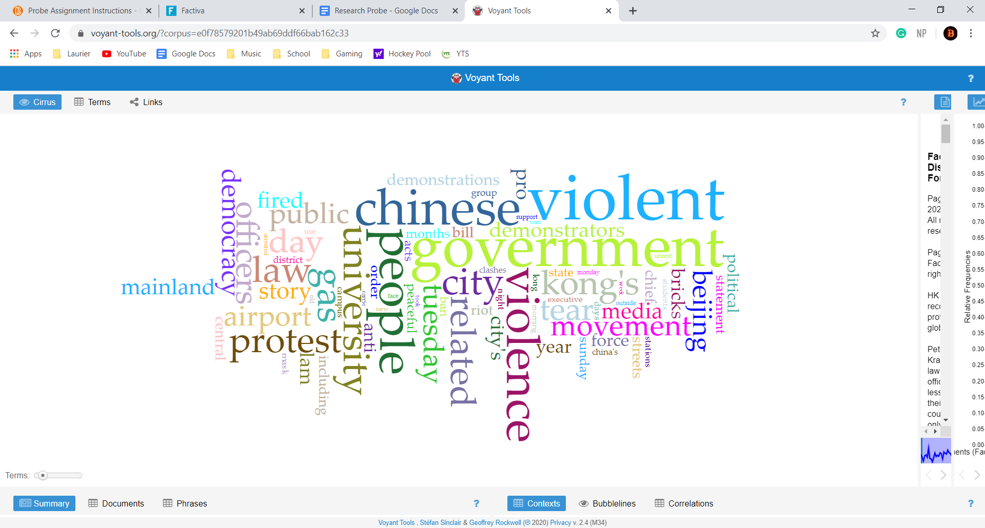

First Word Cloud with Key Search Term: **Violent**

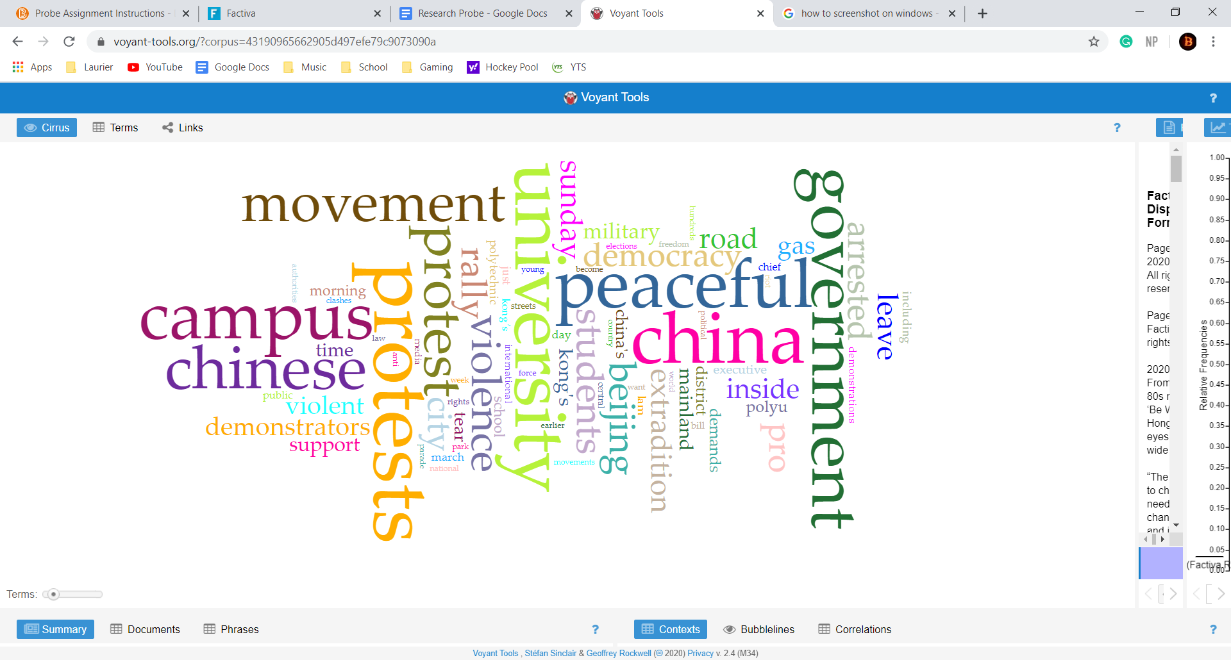

Second Word Cloud with Key Search Term: **Peaceful**